A school keeps the following information about its students:

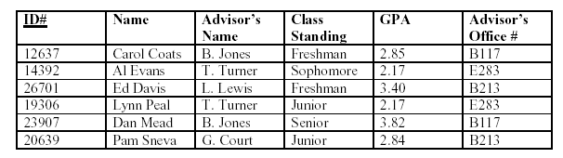

Which normal forms are violated?

Anomalies?